[Date]
Software Arhitecture diagrams
CareerPath
Malamski,Dimitar D.S.
Email: Mitemalamata@gmail.com

Contents
1. C1 – System Context Diagram 2
2. C2 – System Container Diagram 3
3. C3 – System Component Diagram 5
3.1. Backend Container 5
3.2. Frontend Container 7
4. C4 – System Code Diagram 7

C1 – System Context Diagram
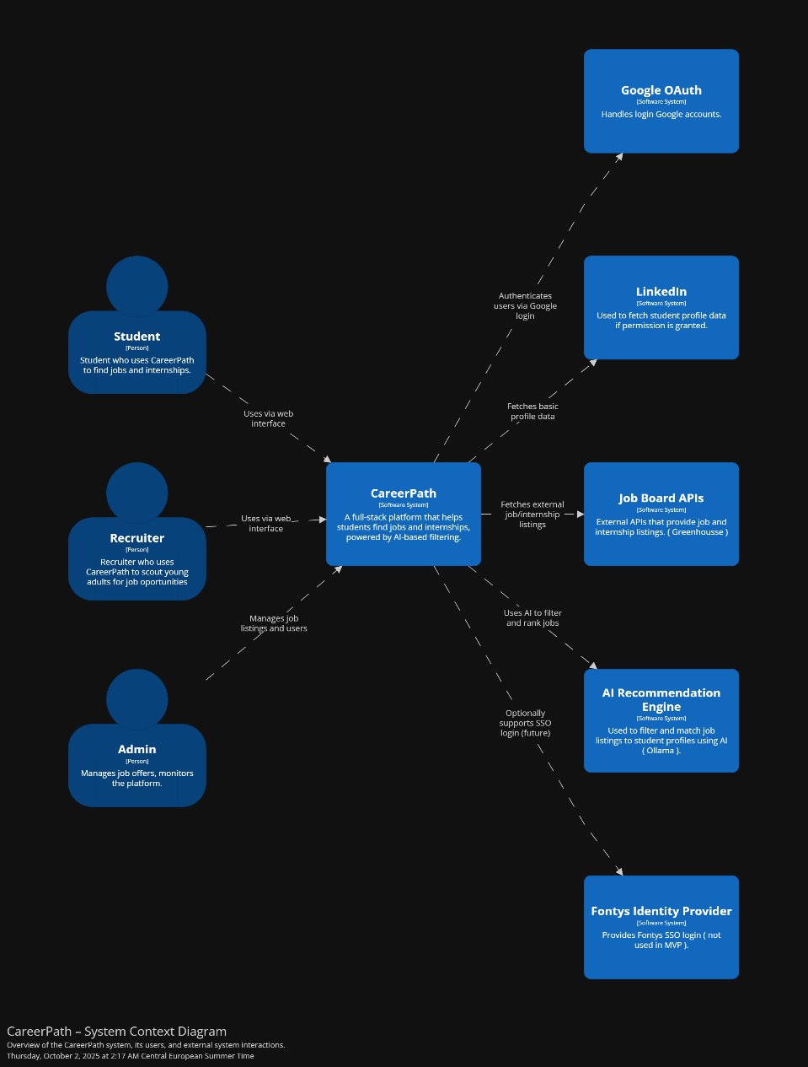

This diagram is the Initial design decision that was made for all the external systems in CareerPath. Duo to time frame on the semester, there were design changes that took place and some of them had to be dropped out in order to complete the MVP of the project.
This is a version of the diagram that showcases how the current external architecture looks

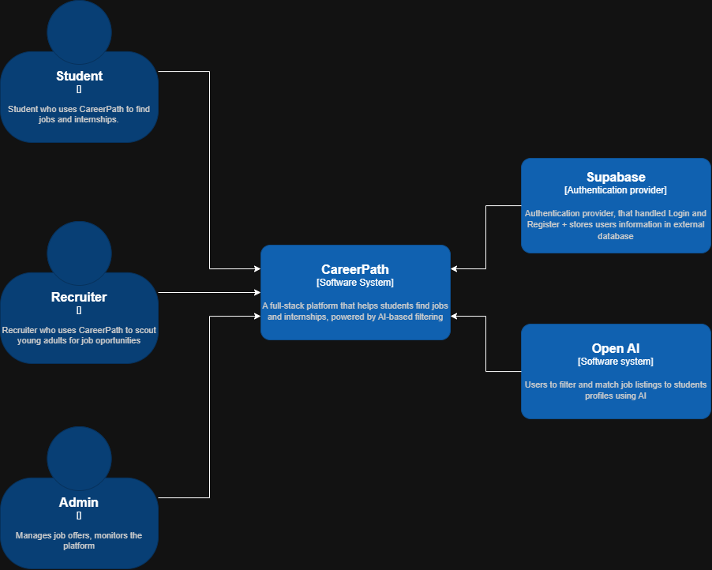

The roles stay the same, but new authentication provider is applied ( Supabase ) for handling Authentication and Authorization. Also, OpenAI is used as an AI engine in the application.

C2 – System Container Diagram
This is how the initial design of the Container Diagram looks like. There are no changes in it besides the switch of the Authentication provider, which was already discussed in the above diagram. The main layers stay the same ( Angular frontend, Java Spring Boot backend, and PostgreSQL DB ).

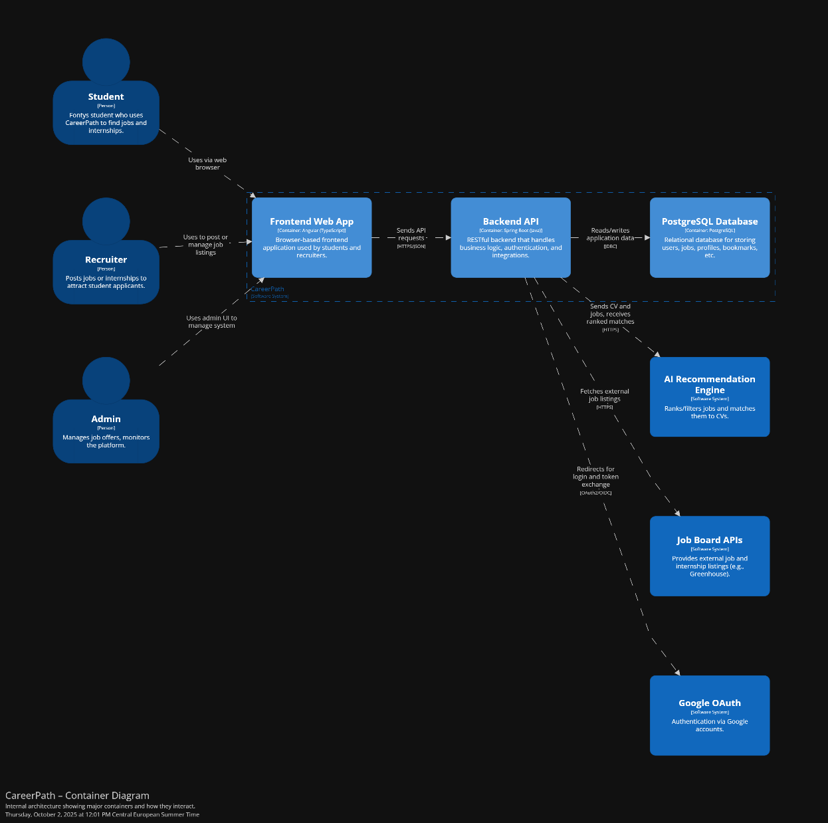

This is how the newly version of the diagram looks like

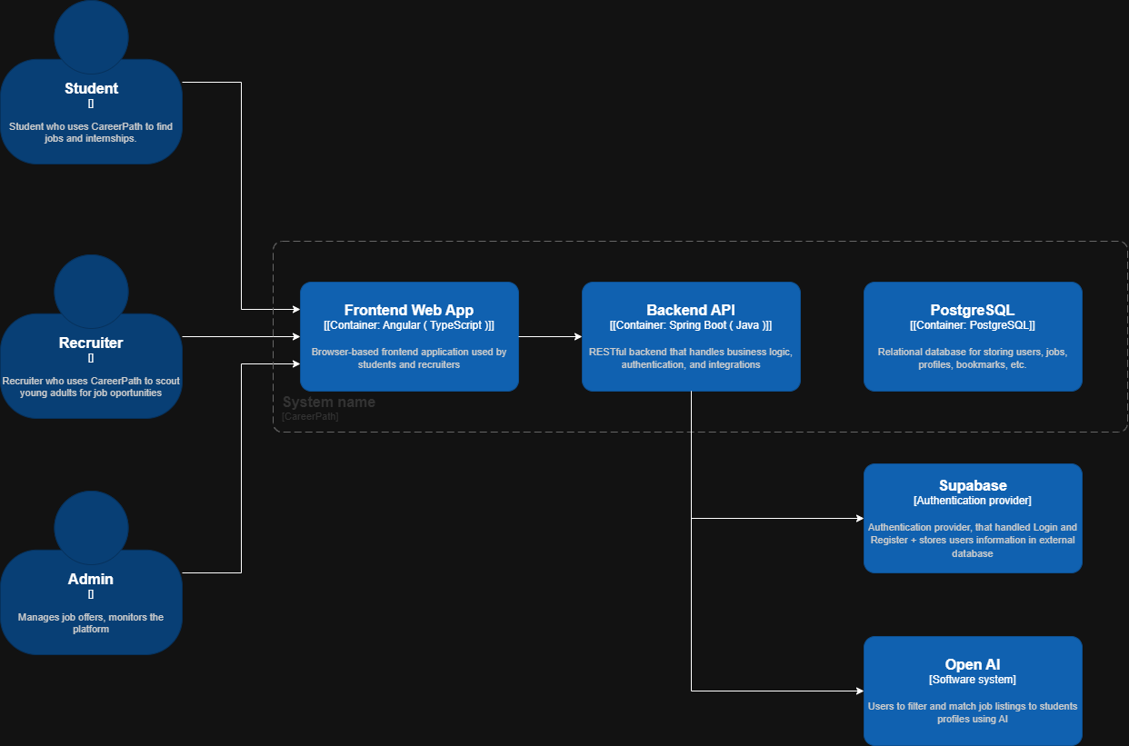

C3 – System Component Diagram

Backend Container
This is an overall of the architecture in the backend I am building in CareerPath. I am using a Hexagonal architecture model, which applies adapters and ports to isolate JPA repositories.
This diagram showcases how data flows from the frontend to the database. Each feature in the application follows this patters.
Current features that follow this patters are the Job listings logic ( JobController ) and the profile creation/editing logic ( ProfileController ). Each one of the has an isolated Controller, Adapter, Service, and a Repository

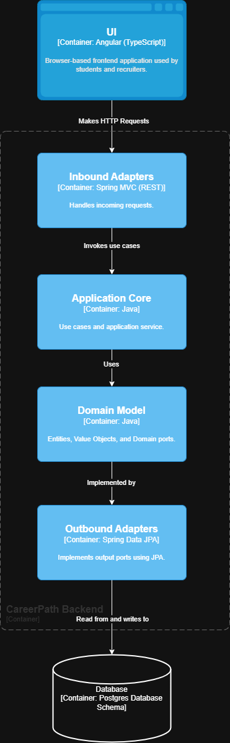

Frontend Container

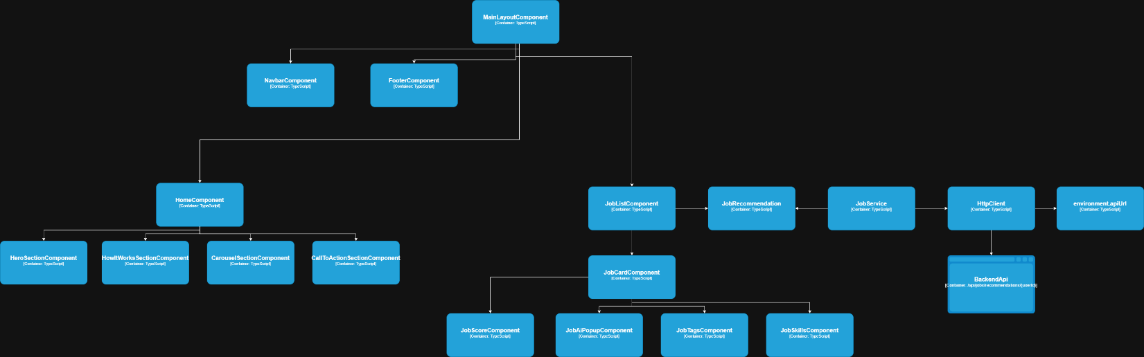
This is how the frontend component diagram looks like as of now. The architecture I am following is pretty standard Agular one, each feature is isolated into a different folder, where all the .ts and .html files are present.
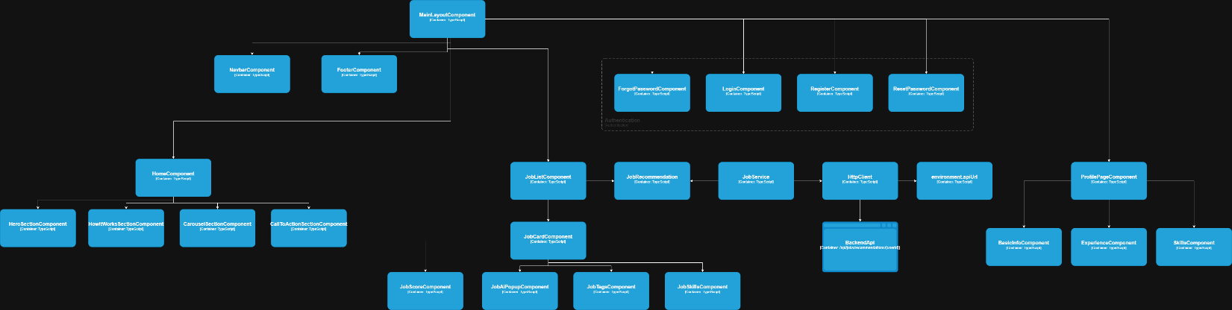
This is the newest version of the diagram, that includes the profile login and the authentication components as well.

C4 – System Code Diagram
This is a code diagram from one of the features in CareerPath ( get Job Recommendations ). It follows the logic from the frontend to the return of the DTO.
